**DAILY ONLINE ACTIVITIES SUMMARY**

|  |  |  |  |  |  |  |  |  |
| --- | --- | --- | --- | --- | --- | --- | --- | --- |
| **Date:** | **10/06/2020** | | | | | **Name:** | **Sathvik R Shetty** | |
| **Sem & Sec** | **6th /B** | | | | | **USN:** | **4AL17CS089** | |
| **Online Test Summary** | | | | | | | | |
| **Subject** | | **SSCD IA Test - 4** | | | | | | |
| **Max. Marks** | | **30** | | **Score** | | | **29** | |
| **Certification Course Summary** | | | | | | | | |
| **Course** | **Web Design** | | | | | | | |
| **Certificate Provider** | | | **Shaw Academy** | | **Duration** | | | **4weeks** |
| **Coding Challenges** | | | | | | | | |
| **Problem Statement:**   1. Python program to find length of list using recursion. 2. Python program to find number of even and odd numbers. | | | | | | | | |
| **Status: Completed** | | | | | | | | |
| **Uploaded the report in GitHub** | | | | | **Yes** | | | |
| **If yes Repository name** | | | | | <https://github.com/sathvikshetty22/Online-Coding> | | | |
| **Uploaded the report in slack** | | | | | **Yes** | | | |

**Online Test Details**

SSCD IA 4 Details:

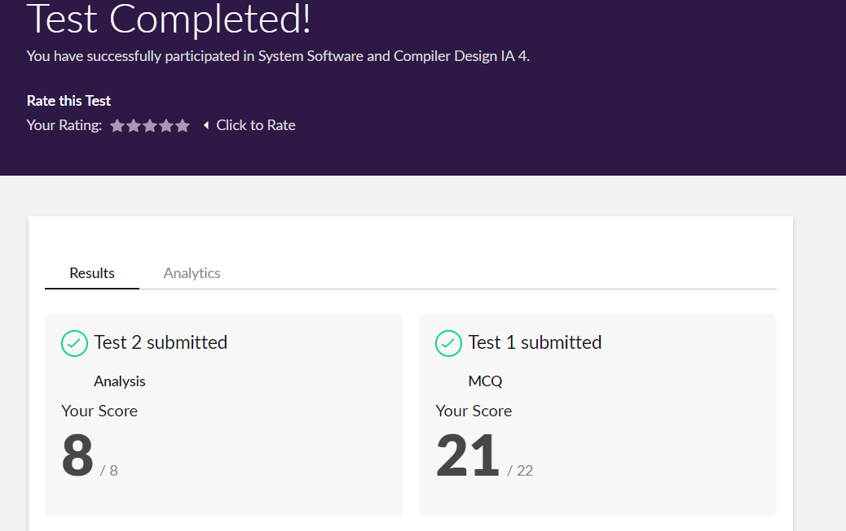

**Online Certification Details**

Lesson

* Digital CV Part 2



**Coding Challenge Details**

1. Python program to find length of list using recursion.

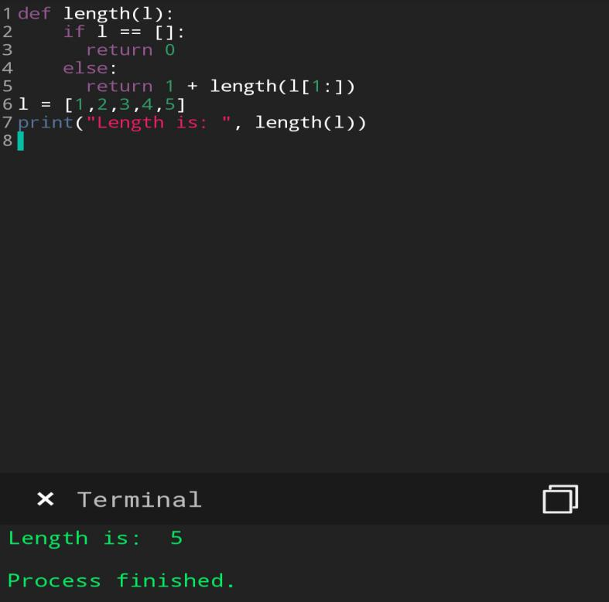

1. Python program to find number of even and odd numbers.

